**1. Blockchain network**

1.1 What is a blockchain network?

* A technical infrastructure that provides ledger and smart contract (chaincode) services to applications.

1.2 The sample network

* a Fabric network N with network configuration NC4 and ordering service O4
* channel C1 is governed by channel configuration CC1. Channel C1 has been established by consortium X1 and X1 contains R1 and R2
* channel C1 is managed by ordering service O and peers P1 and P2 and client applications A1 and A2 have been granted permission to transact on C1
* channel C2 is governed by channel configuration CC2. Channel C2 has been established by consortium X2 and X2 contains R2 and R3
* certificate authorities CA1, CA2, CA3, CA4 certify organization R1,R2,R3,R4 respectively
* Every channel has its own ledger L1 for C1 and L2 for C2 and smart contracts S5 for C1 and S2 for C2

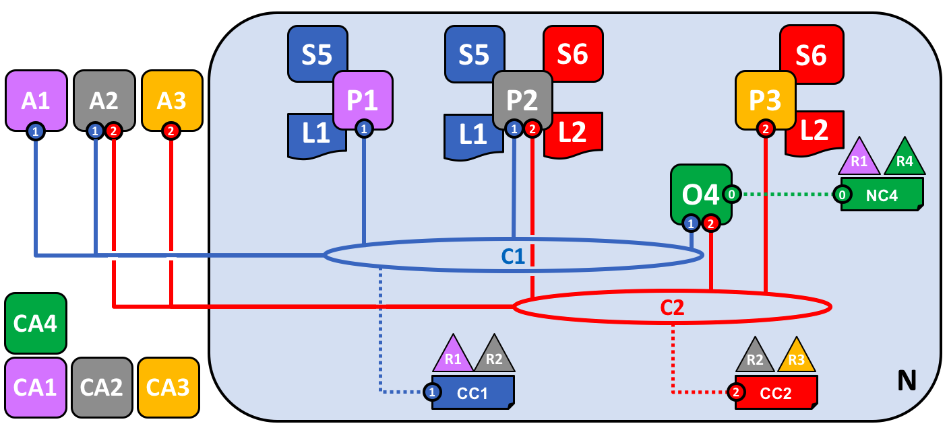

1.3 Creating the Network

* The network N is configured with NC4(Network Configuration 4)
* administered by organization R4
* Certificate Authority(CA4) certify R4 as valid organization
* O4 is orderer node which executes order according to the policies written at NC4.

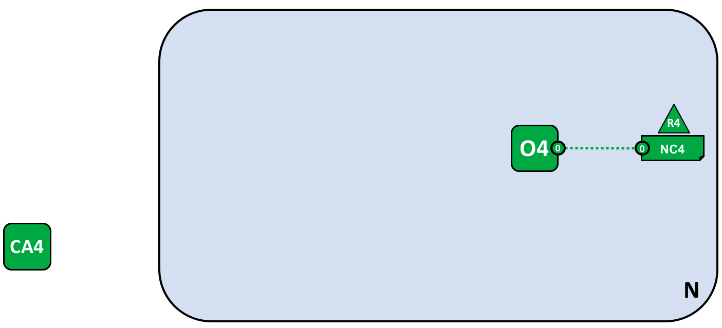

1.4 Certificate Authorities

* used to issue certificates to administrators and to network nodes.
* identify and validate different components and different process.

1.5 Adding Network Administrators

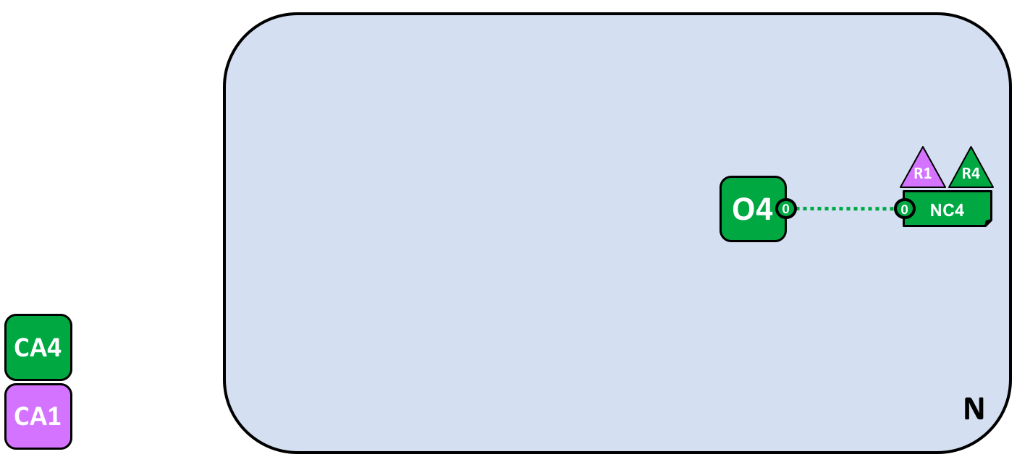

* R4 adds organization R1(certified by CA1) as a new administrator of the network according to the policies
* R1 and R4 have equally shared administrative power on network.

1.6 Defining a Consortium

Consortium means a group with a shared destiny.

* defined by network administrator
* consortium X1 containing R1 and R2(R2 is certified by CA2)
* consortium definition is stored in NC4

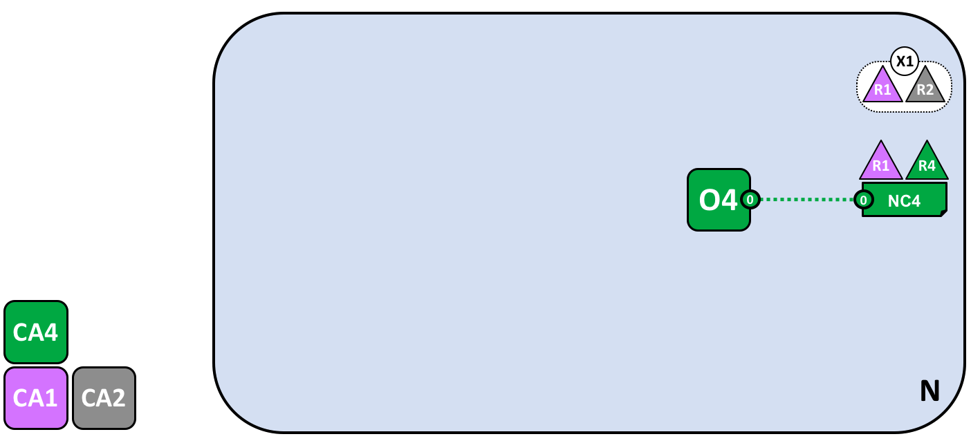

1.7 Creating a channel for a consortium

A channel is a primary communications mechanism by which the members of a consortium can communicate with each other.

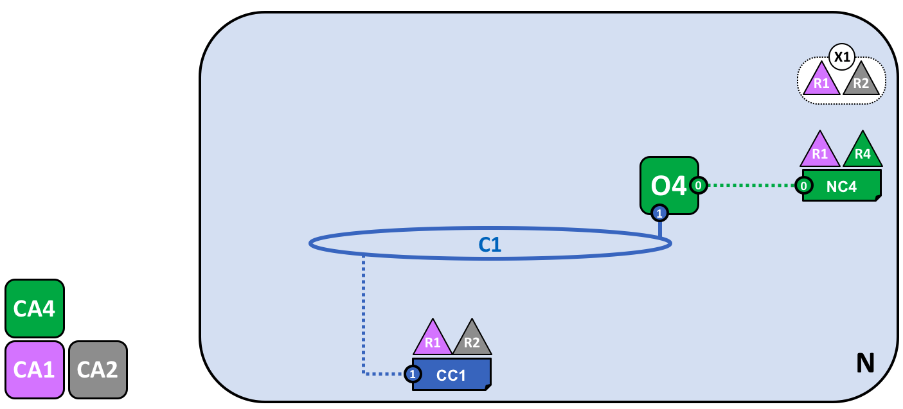

* Channel C1 is created by using the X1
* C1 is governed by a channel configuration CC1
* CC1 is managed by R1 and R2

Importance of channels:

* providing a mechanism for private communications and private data between the members of a channel
* providing privacy from other channels and from networks
* Separate and independent administrative power

1.8 Peers and Ledgers

Peer nodes are the network components where copies of the blockchain ledger are hosted.

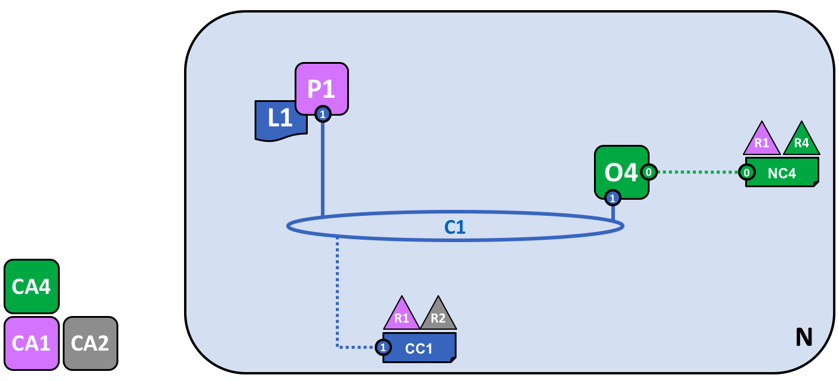

* Peer P1 has joined the channel C1
* P1 physically hosts a copy of the blockchain ledger L1
* P1 and O4 can communicate with each other using channel C1

1.9 Applications and Smart Contract chaincode

A smart contract defines the rules between different organizations in executable code. Applications invoke a smart contract to generate transactions that are recorded on the ledger.

* A smart contract S5 has been installed onto P1
* Client application A1 in organization R1 can use S5 to access the ledger via peer node P1
* A1, P1 and O4 are all joined to channel C1
* A1 has to go through smart contract S5 to invoke the ledger L1

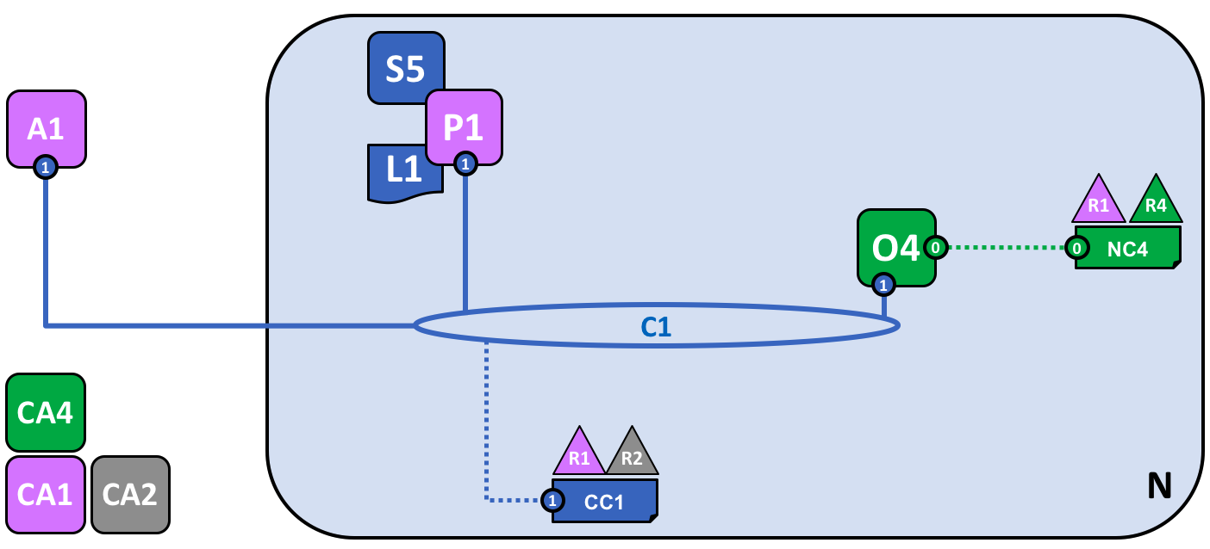

1.10 Installing a smart contract

* After the development of S5, an administrator in organization R1 mustinstall it onto peer node P1

1.11 Instantiating a smart contract

* an administrator in organization R1 must instantiate S5 on channel C1 using P1
* After instantiation, every component on channel C1 is aware of the existence of S5
* S5 can now be invoked by client application A1

1.12 Endorsement policy

Endorsement policy indicates which organizations in a blockchain network must sign a transaction generated by a given smart contract in order for that transaction to be declared valid.

In our sample network

* transactions can be only be accepted onto ledger L1 if R1 or R2 endorse them
* The act of instantiation places the endorsement policy in channel configuration CC1

1.13 Invoking a smart contract

* Once a smart contract has been installed on a peer node and instantiated on a channel it can be invoked by a client application.

1.14 Network completed

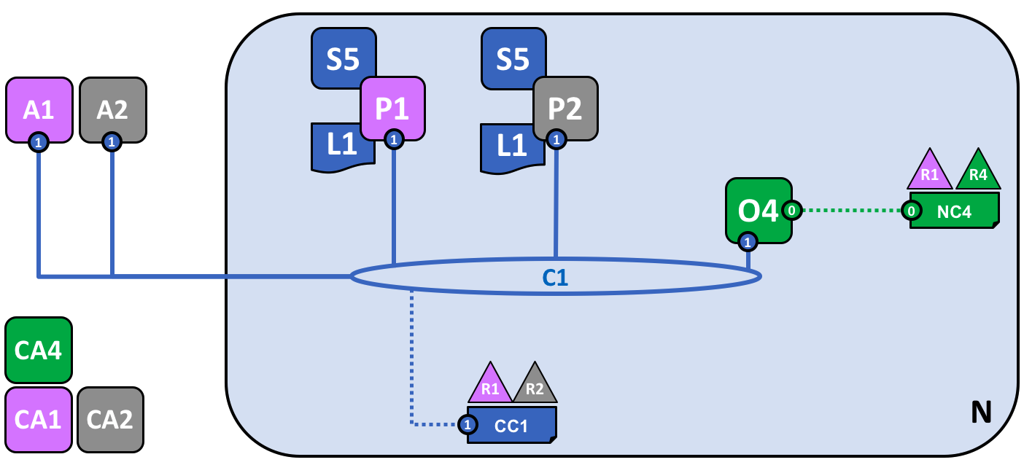

1.15 Generating and accepting transactions

* peer nodes can validate and subsequently accept or reject transactions onto their copy of the ledger L1
* only peer nodes with a smart contract installed can take part in the process of transaction endorsement

1.16 Types of peers

Committing peers

* Every peer node in a channel

Endorsing peers

* Every peer with a smart contract installed on it

Leader peers

* distributing transactions from the orderer to the other committing peers in the organization if the organization has multiple peers in a channel

Anchor peers

* needs to communicate with a peer in another organization

1.17 Install not instantiate

* R2 must install smart contract S5 onto its peer node P2
* Instantiation only needs to happen once

1.18 Simplifying the visual vocabulary

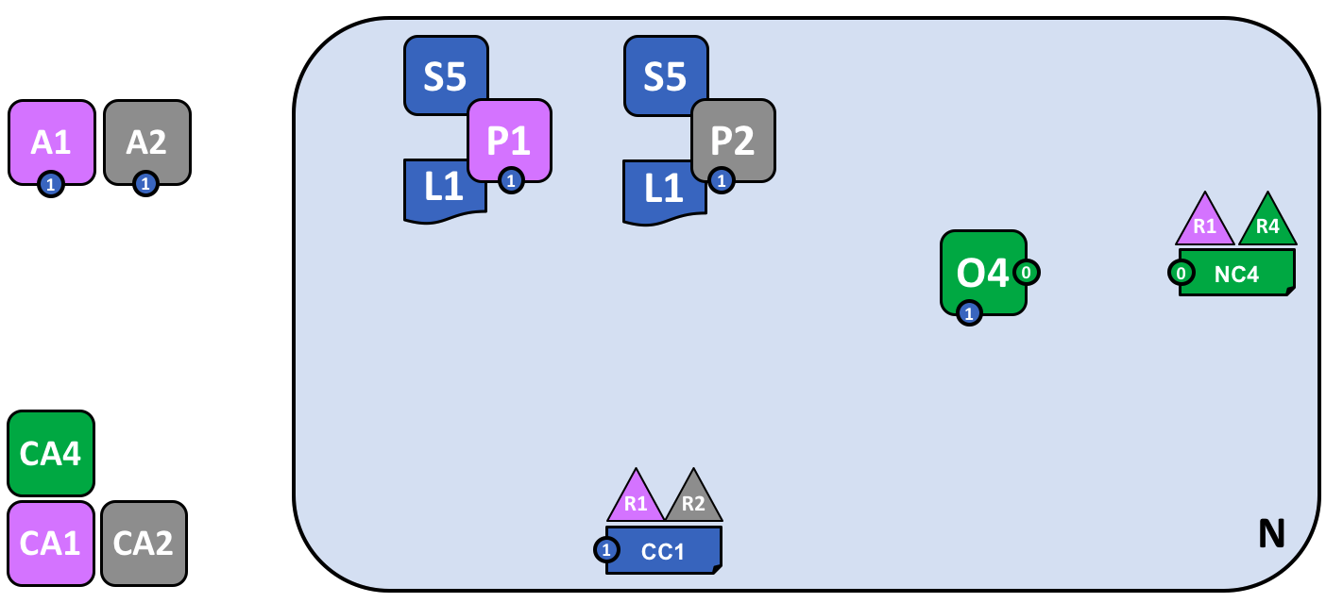

* simplified by replacing lines with points

1.19 Adding another consortium definition

* new consortium X2 for R2 and R3
* R3 is certified by CA3

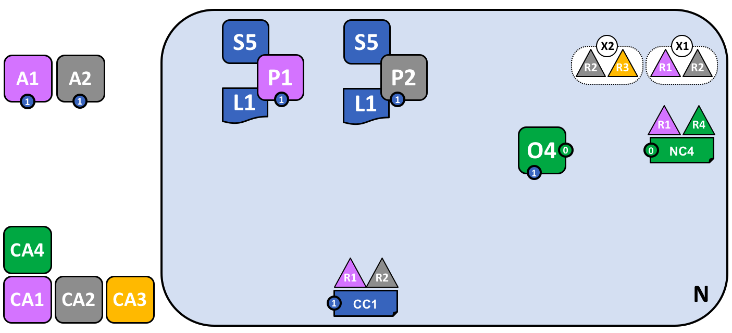

1.20 Adding a new channel

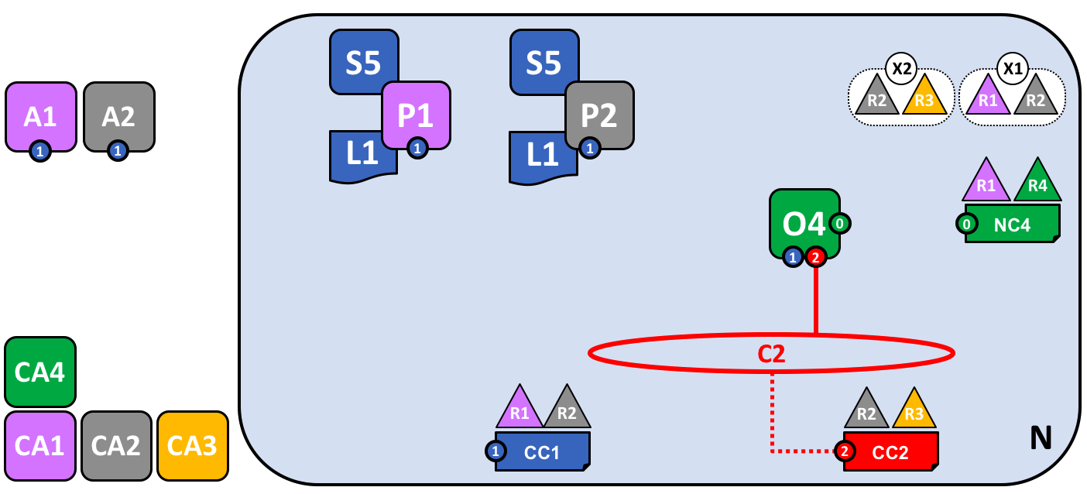

* Channel C2 is created by using the X2
* C2 is governed by a channel configuration CC2
* CC2 is managed by R2 and R3

1.21 Network and channel configurations

* objects are logically singular but physically distributed
* Hyperledger Fabric to be both de-centralized and yet manageable at the same time

1.22 Adding another peer

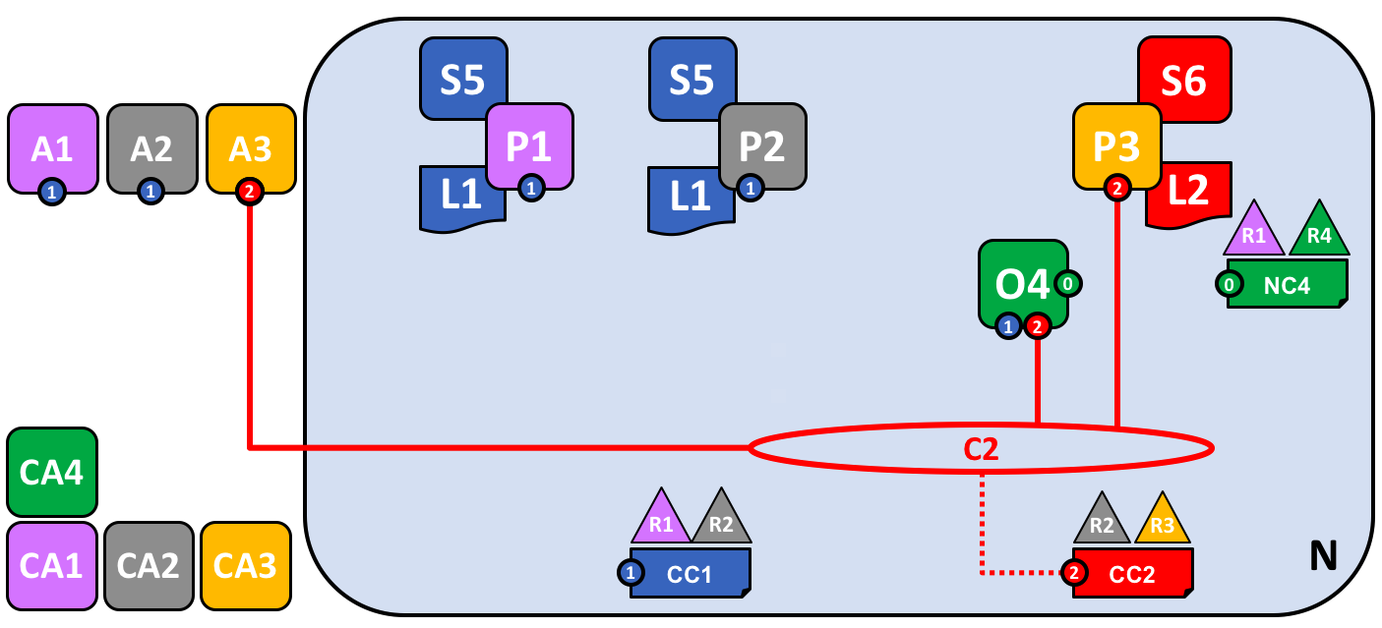

* client applications A1 and A2 can use channel C1 for communication with peers P1 and P2 and ordering service O4 where smart contract S5 is installed in peers and every peer hosts a copy of the blockchain ledger L1
* client applications A3 can use channel C2 for communication with peer P3 and ordering service O4 where smart contract S6 is installed in peers and every peer hosts a copy of the blockchain ledger L2
* ordering service O4 can make use of the communication services of channels C1 and C2
* channel configuration CC1 applies to channel C1, CC2 applies to channel C2

1.23 Joining a peer to multiple channels

* R2 is a member of both X1 and X2
* Client applications A1 can use channel C1 for communication with peers P1 and P2, and ordering service O4
* client application A2 can use channel C1 for communication with peers P1 and P2 and channel C2 for communication with peers P2 and P3 and ordering service O*4*

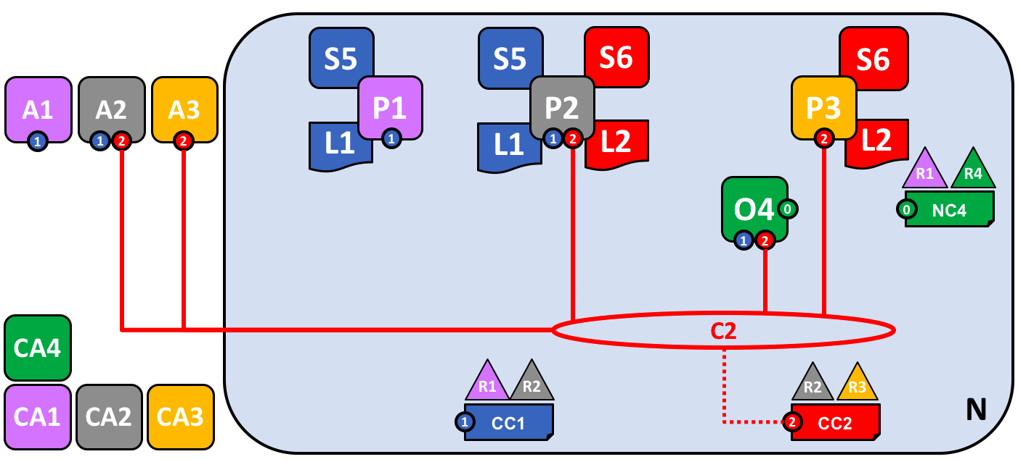

* client application A3 can use channel C2 for communication with peer P3 and P2 and ordering service O4
* Ordering service O4 can make use of the communication services of channels C1 and C2
* Channel configuration CC1 applies to channel C1, CC2 applies to channel C2

1.24 The ordering service

* the component which gathers endorsed transactions from applications
* orders them into transaction blocks

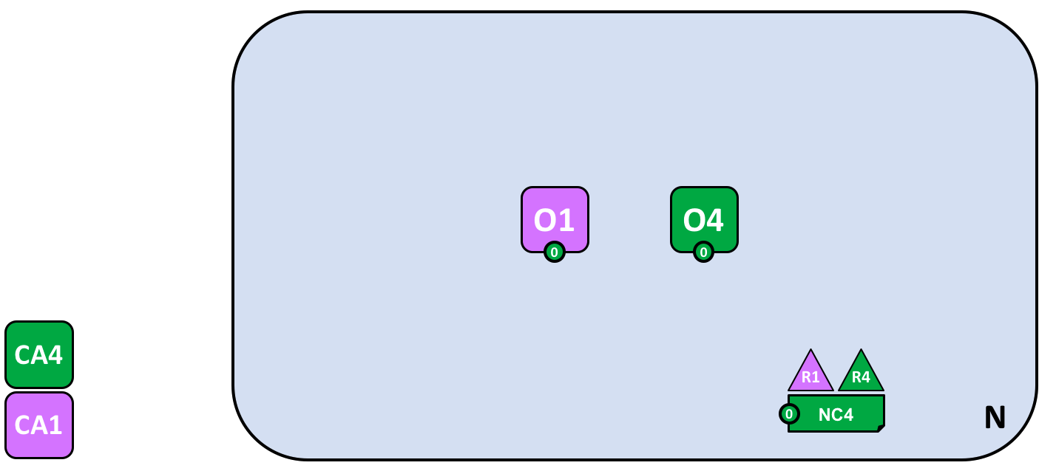

1.25 De-centralized transaction distribution

* No centralized authority
* ordering services is the distribution point for transactions
* ledger is distributed to every peer node in the channel

1.26 Changing policy

* policy change is managed by a policy within the policy itself
* the modification policy(mod_policy) is a first class policy within a network or channel configuration that manages change

1.27 Network fully formed

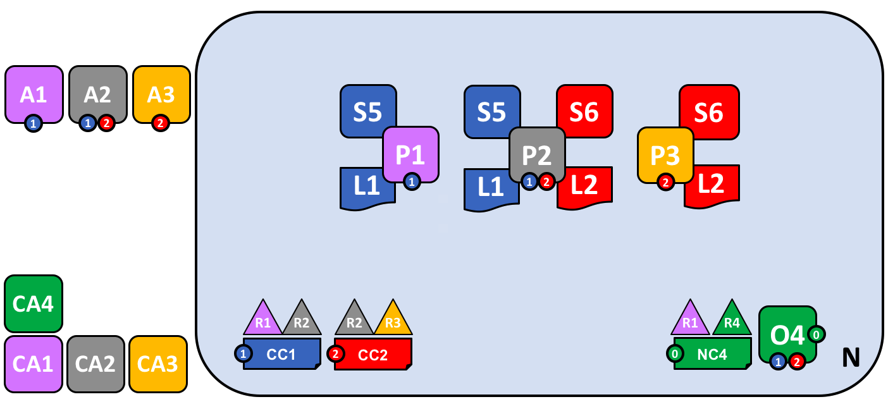

1.28 Summary of network components

* Ledger
* Smart contract
* Peer nodes
* Ordering service
* Channel
* Certificate Authority